**Project Design Phase-II**

**Technology Stack (Architecture & Stack)**

|  |  |
| --- | --- |
| Date | 03 October 2022 |
| Team ID | PNT2022TMID50840 |
| Project Name | Gas leakage monitoring and alerting system |
| Maximum Marks | 4 Marks |

**Technical Architecture:** The Deliverable shall include the architectural diagram as below and the information as per the table1.

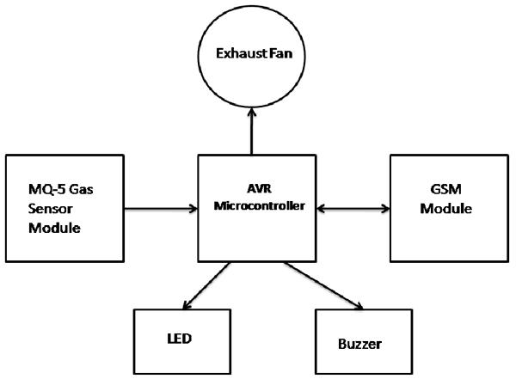

**Guidelines**

**1.** A smart system for device control while LPG gas leakage or fire situations.

2.Two main modules: the detection& transmission module and receiver module

3.The former module detect the change of LPG or CO gas concentration using a special sensing circuit

4.The sensor detects a change in gas concentration, transmitter module activates and sends a signal to receiver module

5.The receiver module activates and control the relay system

**Table. : Components & Technologies:**

|  |  |  |  |
| --- | --- | --- | --- |
| **S.No** | **Component** | **Description** | **Technology** |
| 1. | Gas sensor | A gas sensor is an electronic device which detects dangerous gas leaks in the industrial areas. | * Good sensitivity to combustible gas in wide range. * High sensitivity to propane, butane and LPG. |
| 2. | Flame sensor | Measurement of natural gas entering to the liquefaction terminal.  Process instrumentation used in the liquefaction process | High accuracy flow and quality measurement during loading of the LNG shuttle.  Measurement of LNG, natural gas, (sea) water and odorisation in break-bulk and gasification terminals |
| 3. | LCD Display | **Smoke and gas leakage detectors** are very useful in detecting smoke or fire in buildings, and so are the important safety parameters in order to prevent disasters. | This **MQ135 gas sensor** is sensible to LPG, Alcohol, and Methane etc.It detects the presence of a dangerous LPG leak in your car or in a service station, storage tank environment. |
| 4. | Buzzer | If gas leakage occurs, the system will detects it and makes an alert by buzzing the buzzer attached with circuit. | The number of deaths due to gas cylinder explosions has been increasing day by day. The reasons for such explosions are worn-out regulators, old valves and lack of awareness in handling gas cylinders. |
|  |  |  |  |
| 5. | GSM module | GSM is a mobile communication modem and it is widely used mobile communication system in the world so with the help of GSM module or Nodemcu we can also control the home appliances with the help of Arduino microcontroller | This system will also contain GSM module which can be used to send the alert message to the user. |

.